**Morse Pi Project**

From: Andrew M. & Gozie A.

Discipline: Computer Engineering Technology  
Date: 2/26/2018

# Declaration of Joint Authorship

We Chigozie Aham and Andrew McGuire, hereby declare that this thesis and the work presented in it is entirely our own. Where we have consulted the work of others, this is always clearly stated.

Signed:

Date:

### Approved Proposal

## Executive Summary

As students in the Computer Engineering Technology program, we will be working together to integrate the android software and hardware component of the Morse-Pi project. This proposal requests the approval to integrate the hardware portion that will connect to a database as well as to a mobile device application. The database will store Morse messages and its equivalent translations. The mobile device functionality will provide a more interactive user interface to view data from the hardware functionality.

## Background

The problem solved by this project is to enable ease in the use of Morse code by radio communicators to transmit messages back and forth. This project will facilitate the protection of information by encoding it as well as ensuring ease in decoding it by its listener. Morse code is a predated communication tool used to represent text information in a series of electronic pulses, usually represented as a short pulse (called a "dot") and a long pulse (a "dash"). Only skilled listeners are able to translate and understand Morse codes.

Existing android software products on the market include [1] Morse Transmitters.

In the Computer Engineering Technology program, we have learned about the following topics from the respective relevant courses:

* Java Docs from CENG 212 Programming Techniques In Java,
* Construction of circuits from CENG 215 Digital And Interfacing Systems,
* Rapid application development and Gantt charts from CENG 216 Intro to Software Engineering,
* Micro computing from CENG 252 Embedded Systems,
* SQL from CENG 254 Database With Java,
* Web access of databases from CENG 256 Internet Scripting; and,
* Wireless protocols such as 802.11 from TECH152 Telecom Networks.

This knowledge and skill set will enable us to integrate the hardware and software components.

**Methodology**

This proposal is assigned in the first week of class and is due at the beginning of class in the second week of the fall semester. My coursework will focus on the last two of the 3 phases of this project:  
 Phase 1 Hardware/Software build.  
 Phase 2 System integration.  
 Phase 3 Demonstration to future employers.

*Phase 1 Hardware/Software build*

The hardware and software build has been 80% completed in the past fall term.

*Phase 2 System integration*

The system integration will be completed this winter term.

*Phase 3 Demonstration to future employers*

This project will showcase the knowledge and skills that we have learned to potential employers.

## Concluding remarks

This proposal presents a plan for exploring outdated communication technologies to improve the contemporary technologies. We request approval of this project.

# Abstract

In this project, outdated communication medium was implemented on newer technologies; the solution of encoding messages using Morse code was explored. The Android and Raspberry-pi devices were platforms used to implement this functionality. Exchange of messages between two different parties are possible in 2 different ways:

· From one raspberry-pi to another via direct connection using IP address

· From one raspberry-pi to an Android device via the cloud using hostgator database.

Using two raspberry-Pi devices, the receiving party is only able to view sent messages. Using the raspberry-pi and the Android device, messages could be viewed and sent between the receiving and sending party. The Morse-pi project combines the use of obsolete and current technologies so it promises an even better and secure communication.

**Table of Contents**

Declaration of Joint Authorship iii

Approved Proposal v

Executive Summary v

Background v

Concluding remarks vi

Abstract vii

Illustration List xiii

1. Introduction 1

2. Project Description 3

2.1 Problem 3

2.2 Rationale Behind Project 3

2.3 Project Scope 3

2.4 Software Requirement Specifications 4

2.4.1 Database 4

2.4.2 Mobile Application 5

2.4.3 Web Interface 5

2.4.4 Networked Platform Communication Software 6

2.4.5 Microcontroller Firmware 7

2.5 Project Overview 7

2.5.1 Bill of Materials 7

2.5.2 Time Commitment 8

2.5.3 Mechanical Assembly 8

2.5.4 PCB and Soldering 12

2.5.5 Power Up 12

2.5.6 Unit Testing 13

2.5.7 Production Testing 14

2.6 Problems Encountered 15

2.6.1 Inconsistent Input 15

2.6.2 Debounce Fix 15

2.6.3 LCD touch screen failure 15

2.6.4 Data Communication 15

2.6.5 App Data fetching 16

2.7 Approaches 17

2.7.1 Inconsistent Input 17

2.7.2 Debounce Circuit power 17

2.7.3  LCD touch screen failure 17

2.7.4 Local Data Communication 18

2.7.5 App Data fetching 18

2.8 Walkthrough of System 18

2.8.1 Microcontroller 18

2.8.2 Microprocessor 18

2.8.3 Server 19

2.8.4 Phone Application 19

2.8.5 Website 19

3. Progress Reports 20

3.1 Report 1 20

3.2 Report 2 20

3.3 Report 3 22

3.4 Report 4 23

3.5 Report 5 24

3.6 Report 6 25

4. Build Instructions 27

5. Recommendations 28

6. Technical References 30

7. Appendices 32

7.2 Website Code 48

7.2.1 Main Page 48

7.2.2 Data Page 51

7.2.3 Conversation Page 54

7.2.4 Login Page 60

7.2.5 Account Page 66

7.3 Android Phone Application 78

7.3.1 Main Menu 78

7.3.2 Current Data 92

7.3.3 Morse To Text 96

7.3.4 Text to Morse 100

7.3.5 Morse Letters 104

7.3.6 Morse Graph 108

7.3.7 Channel Page 112

7.3.8 Selected Channel Page 116

7.3.9 Pi Morse History 124

7.3.10 Style 128

7.3.11 Text 129

7.3.12 Login Layout 130

7.3.13 Morse To Text Layout 138

7.3.14 Text to Morse Layout 143

7.3.15 Channel Selection Layout 149

7.3.16 Channel Layout 153

7.3.17 Morse Instructions Layout 155 7.3.18 Settings Layout 159

# Illustration List

2.4a Layout design of the website. p.3

2.5.3a Circuit layout for supplying power to pump. p.5

2.5.3b Circuit layout for sensor connections to microcontroller board. p.6

2.5.3c Finished prototype in acrylic case. p.7

2.5.7a Components in acrylic case before PCB and dividers. p.9

# 1. Introduction

The purpose of the Morse-pi project is to allow for a secure communication between two end-users. The problem solved by this project is to enable ease in the use of Morse code by radio communicators to transmit messages back and forth. This project will facilitate the protection of information by encoding it as well as ensuring ease in decoding it by its listener. Morse code is a predated communication tool used to represent text information in a series of electronic pulses, usually represented as a short pulse (called a "dot") and a long pulse (a "dash"). Only skilled listeners are able to translate and understand Morse codes. The theory behind the project is to apply the rigidity of older technologies and the flexibility of newer technologies to achieve a next-level style of communication.

# 2. Project Description

The Project will incorporate the use of two raspberry pi 3.0, a contact key and a adafruit TTPT 3.5” and a 2.8”touch screen display. The pi’s will connect via the internet and will use the contact keys as input into the system and be recognized as morse that will displayed for the users in text.

## 2.1 Problem

The problem the project solves is the lack of a current physical learning tool for Morse code learners. This project provides a solution that those interested in learning Morse code can set-up and use to assist them in learning Morse with a environment that allows them to send actually messages in Morse and check that the messages they are sending are correctly interpreted.

## 2.2 Rationale Behind Project

The rationale behind the project is that it incorporates many of the skills learned throughout the Computer Engineering Technology course at Humber. This project is a testament to what has been learned throughout the course and displays our skills in: troubleshootings, coding, project management, system design, and working in a team environment. The project also displays our knowledge of: programming, databases, network programming, control systems/microcontrollers, analog to digital systems, and system configuration.

## 2.3 Project Scope

The scope of this project involves the connectivity of two raspberry pis, a website, a database and a app. The raspberry pis have different code in order to establish a network connection between them and so they are able to connect over the internet, and the pis then connect to the database in order to send data to it. The database will have two tables that will be used to store user information and information that has been sent between the pis. The app will have both an offline and online function. While online the app will be able to access the data from the database in order to be displayed upon the app in both text and in morse in order to help improve the users understanding. The app interfaces with the database via a php server that fetches information from the database in order for the app to be able to easily access it. The website will connect to the database and be able to fetch data and modify and remove messages in order to grant user control.

## 2.4 Software Requirement Specifications

### 2.4.1 Database

### 2.4.2 Mobile Application

### 2.4.3 Web Interface

### 2.4.4 Networked Platform Communication Software

### 2.4.5 Microcontroller Firmware

### 2.5 Project Overview

## 2.5.1 Bill of Materials

## 2.5.2 Time Commitment

## 2.5.3 Mechanical Assembly

## 2.5.4 PCB and Soldering

## 2.5.5 Power Up

## 2.5.6 Unit Testing

## 2.5.7 Production Testing

## 2.6 Problems Encountered

### 2.6.1 Inconsistent Input

### 2.6.2 Debounce Fix

### 2.6.3 LCD Touchscreen Failure

### 2.6.4 Data Communication

### 2.6.5 App Data Fetching

## 2.7 Approaches

### 2.7.1 Inconsistent Input

### 2.7.2 Debounce Circuit power

### 2.7.3 LCD touch screen failure

### 2.7.4 Local Data Communication

### 2.7.5 App Data fetching

## 2.8 Walkthrough of System

### 2.8.1 Microcontroller

### 2.8.2 Microprocessor

### 2.8.3 Server

### 2.8.4 Phone Application

### 2.8.5 Website

### 3. Progress Reports

## 3.1 Report 1

|  |  |
| --- | --- |
|  |  |
|  | |
|  | |

## 3.2 Report 2

|  |  |
| --- | --- |
|  |  |
|  | |
|  | |

## 3.3 Report 3

|  |  |
| --- | --- |
|  |  |
|  | |
|  | |

## 3.4 Report 4

|  |  |
| --- | --- |
|  |  |
|  | |
|  | |

## 3.5 Report 5

|  |  |
| --- | --- |
|  |  |
|  | |
|  | |

## 

|  |  |
| --- | --- |
|  |  |
|  | |
|  | |

# 4. Build Instructions

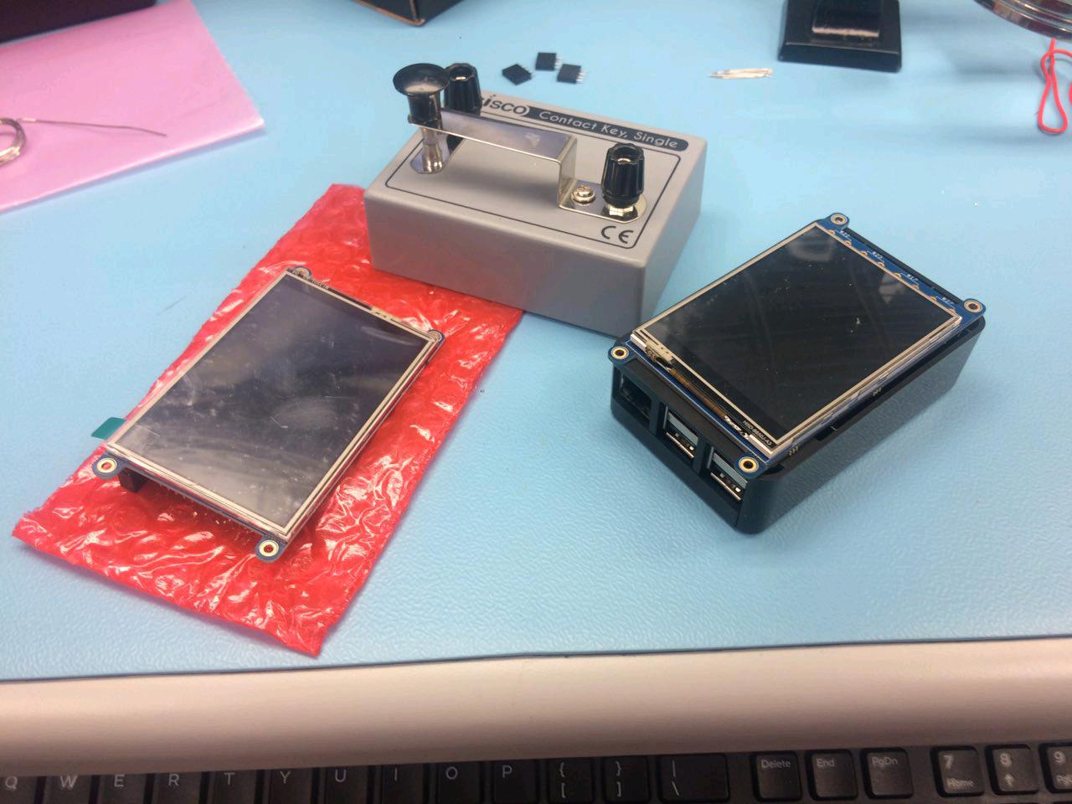

### Cost

The cost of this project varies, its possible to do this project with a single raspberry pi however the full functionality is designed for two.

Here's what you'll need

PiTFT plus 320x240 3.2" cost $39.95CAD Canakit Raspberry PI 3 complete Starter Kit 32 GB edition cost $99.99CAD Eisco Labs Contact Key, Telegraphing/Morse Code, Single cost $9.77CAD

total cost after taxes $169.18CAD(338.34)

Other things you'll need

Some wire and cutters soldering iron and solder (Don't forget your safety glasses) jumper wires two cables with an alligator clip on one end and a banana clip on the other Keyboard, (No mouse required the touch screen handles that well) And last but not least if you are trying to connect the two raspberry pis you'll need a internet connection.

### Time

This project shouldn't take more than a few days assuming every day half an hour to and hour is spent

### Assembly

Assembly of the project is fairly straightforward however some soldering is required. WARNING purchasing the pitft as a kit will require some more soldering, here is a link that will assist in guiding you through that. <<https://learn.adafruit.com/adafruit-pitft-28-inch-resistive-touchscreen-display-raspberry-pi/assembly>

1. So if you noticed the touch screen had 8 component holes, here you'll need to solder wire, or what I suggest clipping part of a resistor and soldering two of those into the component holes labeled with #27 on the bottom right. Note be careful with soldering these leads on as if you heat the component hole too much it is possible to damage the touch screen, speaking out of personal experience here.
2. after the component has cooled down connect jumper wires to the two pins, then connect the alligator clip to the one end of the jumper (some wire required first) and then the banana clip fits perfectly to the Eisco Contact Key.
3. Next part is simple you only need to connect the touch screen to the raspberry pi the screen should fit over top of the pi in a way that if covers the pi, If the screen looks like it hangs off the bottom of the pi you have the screen upside down so turn it around and plug it in again. If any of the pins of the touch screen is not connected it is not connected correctly make sure all pins are connected and the orientation of the screen is correct.
4. Here is what it should look like

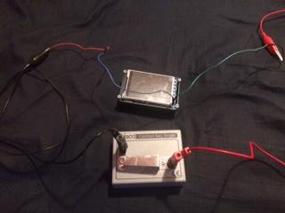

### Configuration

Before plugging in the sd card that comes with the raspberry pi there are some steps that need to completed before testing things out.

1. first step is image the raspberry pi, in order to do this download the image here <<https://learn.adafruit.com/adafruit-pitft-28-inch-resistive-touchscreen-display-raspberry-pi/easy-install>
2. if you have software to burn an image on the an sd card you can skip this step. after you have downloaded the image you'll need to be able to burn it onto the sd card some software is required. Etcher is the software that I used to burn the image onto my sd card, however if you have other software you can use that but for those who don't here is the link to download Etcher, after downloading go ahead and install <https://etcher.io/>
3. if your sd card is formatted to exFat or you can format it yourself to exFat skip this skep. Etcher is fortunately fairly simple to use however before just running it and burning the image you'll need to make sure the sd is formatted to exFAT there is software somewhere out there in the internet here is a link to what I used, download and install and format your sd card to exFat <<https://www.sdcard.org/downloads/formatter_4/>
4. Now after the SD formatter is installed, connect the sd card with the sd card reader that comes in the raspberry pi kit. Make sure that when using the formatter to format the sd card to verify that is formatted to exFat or the card may can fail to have the imaged burned to it.
5. After formatting the sd card next is to use Etcher to burn the image to the card, and back to the point I made two steps ago, Etcher is fairly straightforward to use. First you select the image that you will burn, this will be the file unzipped that was obtained in step 1 after selecting the image, next make sure you select your sd card. The last thing to do here is to click Flash!, this will take a while so you might as well go make some tea or whatever.
6. Now you can plug in the raspberry pi and start it up. If the pitft display displays bright white and remains in that state for longer than 5 minutes its possible something has gone wrong with the installation, if that is the case verify that you have installed the correct image and restart the process.
7. Now that the Raspberry pi has started there are a few things you'll need to do. First you need to go the Raspberry pi configuration. To navigate to it you can click on the start menu -> Preferences -> Raspberry Pi Configuration, while in here you'll want to change a few things set up for the pi. In the system tab you can change your password and host name for your raspberry pi(This is a safety option).Next go to the Interfaces tab, in here you will want to enable SSH , VNC , PSI, and I2C. SSH and VNC are just to allow you to use other tools in order to access the PI remotely, I will be going over the SSH use but the VNC use isn't necessary.
8. Now that your Pi is configured you need to get the software to run everything, here are a few options of how you can get that done. After getting an internet connection on the raspberry Pi you can navigate to its internet browser and go to <<https://github.com/Joemiddle/TouchPi-CENG317/tree/master/software> here you will see three important python files(They are the ones that end in .py) download them all on the raspberry pi. After downloading them to the raspberry pi you can move them from the downloads folder to another folder at your own discretion However for ease of use I suggest making a folder in the root of the user and then running the python code in that folder. The other way of getting these files onto the raspberry pi is the putty way on your computer not the pi. first download and run putty link below <<http://www.putty.org/> after you download putty you'll still need to establish an internet connection on the pi. Now on the Pi you need to go to the a terminal window by clicking on the start menu-> Accessories -> Terminal. Once in the terminal type in ifconfig which will let you find the ip address of the raspberry pi, if you are connecting to a local private network it will probably be something along the lines of 192.168.0. 1 to 255 after that you will type that into putty as the Host Name (or IP address) and click open at the bottom it will prompt you for username / password so make sure you know it if you left it as the default it will be pi / raspberry. Now on your computer you will want to open the python files in notepad or notepad++. Copy the content of the file and paste it into the same file name, you can make a file and start editing it with the command sudo nano (filename). so and example of it is to copy the content of the file clientCode.py and then on the pi create that file and start editing it with "sudo nano clientCode.py" all in one line. Now you just paste what you copied from clientCode.py to save you can press CRL + X and then y and then enter. Repeat this process for all the files codeServer.py and tcpmorse_lookup.py. Now the Pi should be ready.
9. This step is the longest process... You've got to configure the second raspberry pi, the fortunate part to this part is you've done it all before, after you've finished the second pi you're done setting everything up and its onto testing.

### Run

To run you need to the ifconfig on both of the pis in order to get their ips, make sure to make a note of it. Now you need to make one pi the server and the other the client, it doesn't matter which one is which but you need to type in different commands for each

The server needs to run its command first sudo python3 ./codeServer.py

The client can then run its code with this command sudo python3 ./clientCode.py

After that both screen should display ready and if both have correctly connected you will be able to send a message to the other pi by typing in morse. the pi you send the message on will be able to hear the morse however the won't see the message, the message will display on the other pi. And with that it's done!

I hope you've may of learned a bit about the Raspberry Pi running through this process or maybe a bit if you've looked at the python code however that's all folks!

### Database build

The database functions with two tables. The first table contains information about users, that has three fields: Username, UserId (Primary Key, auto_increment), and password(hashed). The other table is the conversation table and it has 4 fields: MessageId(primary key, auto_increment), sender(foreign key), receiver(foreign key), and data (stored in text, not morse). The database is on its own private sql server and is accessed by the raspberry pi and the android app in order to fetch and upload data.

# 5. Recommendations

# 6. Technical References

# 7. Appendices

# 7.2 Website Code 7.2.1 Main Page 7.2.2 Data Page 7.2.3 Conversation Page 7.2.4 Login Page 7.2.5 Account Page 7.3 Android Phone Application 7.3.1 Main Menu 7.3.2 Current Data 7.3.3 Morse To Text 7.3.4 Text to Morse 7.3.5 Morse Letters 7.3.6 Morse Graph 7.3.7 Channel Page 7.3.8 Selected Channel Page 7.3.9 Pi Morse History 7.3.10 Style 7.3.11 Text 7.3.12 Login Layout 7.3.13 Morse To Text Layout 7.3.14 Text To Morse Layout 7.3.15 Channel Selection Layout 7.3.16 Channel Layout 7.3.17 Morse Instructions Layout 7.3.18 Settings Layout

# 